AudioBook Listening Event

for Graduates of The Landmark Forum*

Daniel Benway, David Young, and Alice Foeller are inviting graduates of The Landmark Forum (and est) to Gahanna, OH on Saturday, June 27, 2015 from 10am-noon Eastern Time so that we may all listen to ‘Insights & Distinctions, Landmark Essays, Volume 1’, an AudioBook from Landmark Worldwide, presented by Nancy Zapolski, and Joe DiMaggio. This is NOT an official event of Landmark Worldwide. This is NOT an opportunity to register into the Landmark Forum.

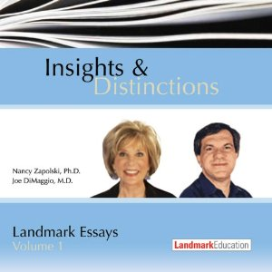

|  |  |
| --- | --- |
| **Who?**  **What?** | Graduates of The Landmark Forum (and est)  AudioBook Listening and Discussion Event. This is NOT an official event of Landmark Worldwide. This is NOT an opportunity to register into the Landmark Forum. |
| **When?** | Saturday, June 27, 2015 10am-noon Eastern Time |
| **Where?** | 676 Brook Hollow, 2nd Floor, Gahanna, OH 43230 |
| **Why?** | So that we may come together as a community in Columbus, OH and further our understanding and usage of the insights and distinctions of Landmark Worldwide. |
| **How?** | To reserve your spot, or for more information, please visit <http://www.ColumbusGrads.org>. Please bring a notepad and a pen to the event so you can take notes. |